

Practices for Secure Software Report

Table of Contents
Document Revision History 3
Client 3
Instructions 3
Developer 4
1. Algorithm Cipher 4
2. Certificate Generation 4
3. Deploy Cipher 5
4. Secure Communications 5
5. Secondary Testing 6
6. Functional Testing 6
7. Summary 7
8. Industry Standard Best Practices 7

Document Revision History

Version | Date | Author | Comments
1.0 | October 20, 2026 | Nathan Burlison | Code refactor and local evidence; web/scan tests pending

Client



Instructions

Prepared for Artemis Financial by Global Rain. This report documents the provided Java application, the planned HTTPS controls, SHA-256 checksum verification, certificate generation, and the results that could be established in the available build environment.

- Demonstration scope: a Spring Boot web API for checksum calculations and verification, not a complete financial data platform.
- Evidence rule: actual Keytool and standalone JDK test captures are included. Screenshots that require running the Spring server or OWASP scanner are clearly marked pending.
- Remaining validation must be run in Eclipse or another network-enabled Maven environment before final course submission.

Developer
Nathan Burlison | Developer, Global Rain | CS 305 Project Two

Algorithm Cipher

Recommendation: use TLS 1.3 for client-server traffic, preferring the AES-256-GCM authenticated-encryption cipher suite (TLS_AES_256_GCM_SHA384) when supported. Keep SHA-256 as a separate checksum function for integrity verification. A checksum is not an encryption cipher, and TLS encryption is not the same operation as the application-level digest.
AES is a symmetric-key block cipher with 128-bit blocks; the recommended option uses a 256-bit session key. Galois/Counter Mode (GCM) encrypts the message and creates an authentication tag so modified ciphertext is rejected. TLS 1.3 uses an authenticated ephemeral key exchange to establish shared traffic secrets, and the SHA-384 function in the named suite participates in HKDF-based key derivation. The cipher suite actually negotiated depends on the TLS provider and client, so successful negotiation must be checked rather than assumed.
For the standalone checksum, SHA-256 produces a 256-bit (32-byte, 64-hex-character) digest from UTF-8 input. The code checks a trusted expected digest using MessageDigest.isEqual. Changing one character normally changes the digest. A hash has no symmetric or asymmetric key; when an attacker can modify both data and its checksum, a plain hash does not authenticate the sender. Use HMAC-SHA-256 or a digital signature for authenticated data integrity.
Randomness and keys: the Java TLS implementation supplies cryptographically secure handshake randomness and ephemeral shared secrets. The generated localhost certificate has a 3,072-bit RSA public/private key pair, with a SHA256withRSA certificate signature. RSA identifies the local service; AES protects session traffic. A secure random GCM nonce must never repeat with the same symmetric key; TLS stacks manage records and nonces rather than using manually generated IVs in this code.
History and current state: DES and 3DES were superseded by modern AES, and obsolete SSL/TLS 1.0/1.1 configurations should not be used. TLS 1.3 reduces obsolete handshake and cipher choices. NIST SP 800-52 Rev. 2 recommends modern TLS configuration, and NIST FIPS 180-4 standardizes SHA-256. In this project TLS 1.3 is configured in application.properties; the local self-signed certificate is only a development identity, not a production trust solution.

Certificate Generation
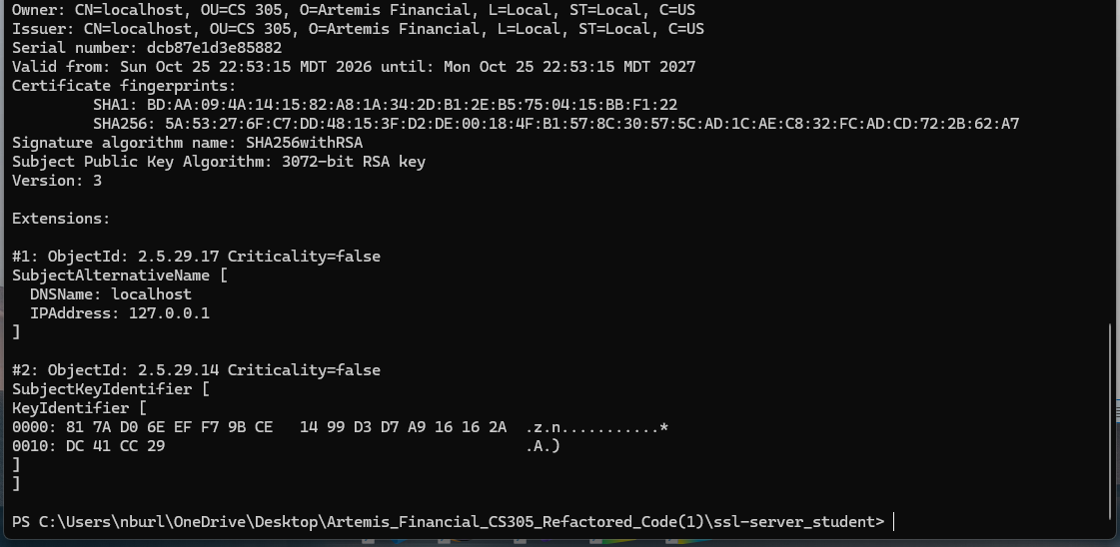

Deploy Cipher
The refactoring adds HashService.java (SHA-256, UTF-8, hexadecimal output, and digest comparison), HashController.java (GET /hash sample and POST /verify), and tests. The output below was produced by compiling HashService.java and ChecksumSmokeTest.java with Java 21 and executing the standalone checksum test.
Unique test data: Artemis Financial | Nathan Burlison | CS305 Project Two | 2026-10-25 | 7f42c9. The expected SHA-256 digest from the verified JDK result is ca6a66947f82e30ce8abbb602944c1ed21b6885ad35fec198a0ed49daee1191a. The original string passes and an altered string fails. A standard known-answer test for “abc” also passes.

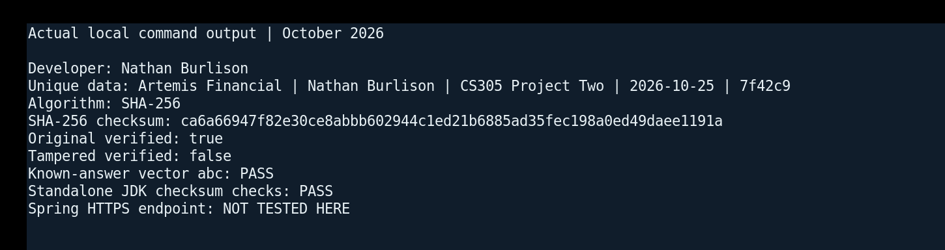

Result: standalone SHA-256 implementation VERIFIED. Application-level GET /hash and POST /verify must still be exercised after the Spring Boot build succeeds.

Secure Communications
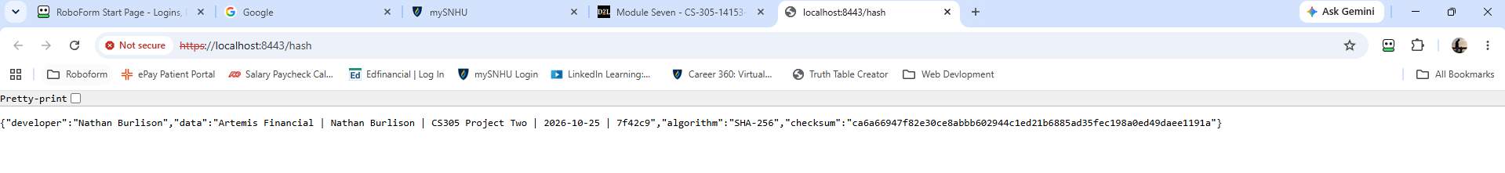

Secondary Testing
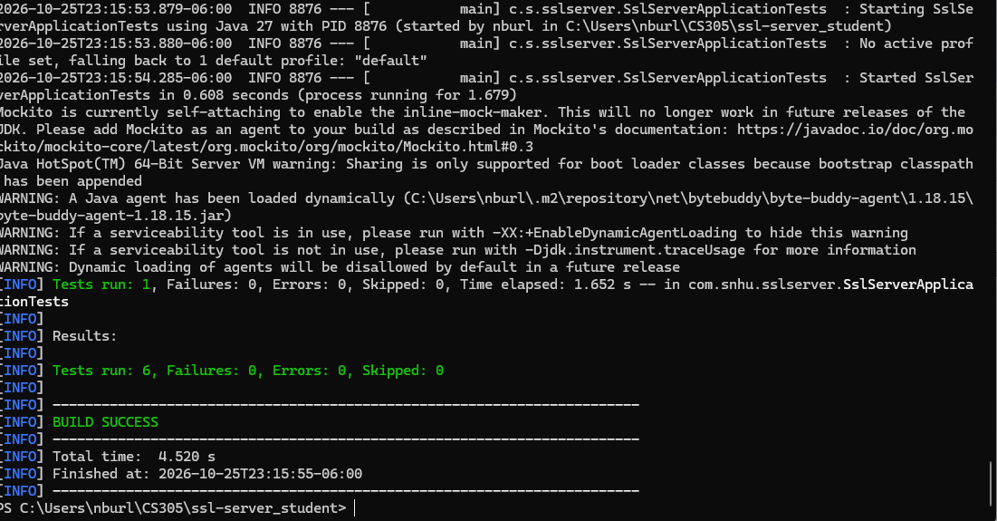

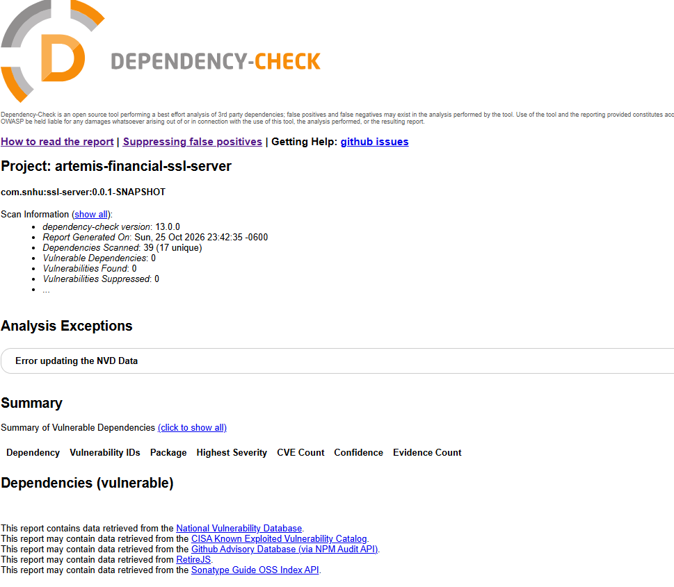

Functional Testing

Summary

Refactoring followed a defense-in-depth process: (1) identify missing route and incomplete SSL configuration; (2) update out-of-date framework and testing dependencies; (3) generate a localhost RSA certificate with SANs and keep the private key out of the project ZIP; (4) add TLS 1.3 transport settings; (5) implement SHA-256 digest creation and comparison; (6) add unit tests and execute the tests possible without external libraries; and (7) plan an OWASP dependency scan and browser verification when full Maven execution is available.
In a vulnerability-assessment process flow, these changes address identifying weaknesses, defining controls, implementing fixes, and retesting. Key controls include confidentiality and authenticity of the HTTPS session, integrity checking of received data, limits on input, and credential handling. Certificate trust, privileged access, telemetry, dependency validation, and real file-processing requirements remain separate production concerns.
Code-file attachments are contained in the accompanying ZIP: SslServerApplication.java, HashService.java, HashController.java, application.properties, pom.xml, three JUnit test files and a standalone smoke test, two Keytool setup scripts, and evidence files. The .p12 private-key file is intentionally NOT distributed; scripts create it on the recipient machine.

Industry Standard Best Practices

I used maintained cryptographic primitives from the Java runtime rather than writing a custom cipher; a standards-based SHA-256 digest; TLS 1.3 and PKCS12 settings; a subject-alternative-name certificate; separation of the public CER and private key; environment-based password configuration; small request validation; and automated integrity-test cases. These choices support secure defaults and help developers avoid predictable mistakes such as obsolete digests, custom encryption routines, or passwords embedded in source control.
Industry best practices also require verifying third-party components. The refactor upgrades legacy dependencies, removes an unnecessary starter, and includes a modern OWASP dependency-check plugin. The expected final workflow is review, test, scan, remediate, and rerun. Since that scan was blocked here, compliance cannot be certified from the existing evidence. The report states that limitation rather than incorrectly treating the new versions as vulnerability-free.
For Artemis Financial, disciplined security practices reduce the chance of exposing personal and financial information, protect customer confidence, support auditability, and lower breach-related business risk. Development-only self-signed certificates are not appropriate public trust anchors. A production release would additionally require CA-managed TLS certificates, authentication and authorization, secrets management, secure file handling, logging, monitoring, and deployment security reviews.

References
National Institute of Standards and Technology. (2019). Guidelines for the selection, configuration, and use of TLS implementations (SP 800-52 Rev. 2). https://csrc.nist.gov/pubs/sp/800/52/r2/final
National Institute of Standards and Technology. (2015). Secure Hash Standard (FIPS 180-4). https://csrc.nist.gov/pubs/fips/180-4/upd1/final
IETF. (2026). The Transport Layer Security (TLS) Protocol Version 1.3 (RFC 9846). https://www.rfc-editor.org/info/rfc9846/
OWASP. (2026). Dependency-Check. https://owasp.org/projects/Dependency-Check
Spring. (2026, October 23). Spring Boot 4.1.2 available now. https://spring.io/blog/2026/10/23/spring-boot-4-1-2-available-now/
Spring. (2026). Build systems: Maven starter dependencies. https://docs.spring.io/spring-boot/reference/using/build-systems.html

